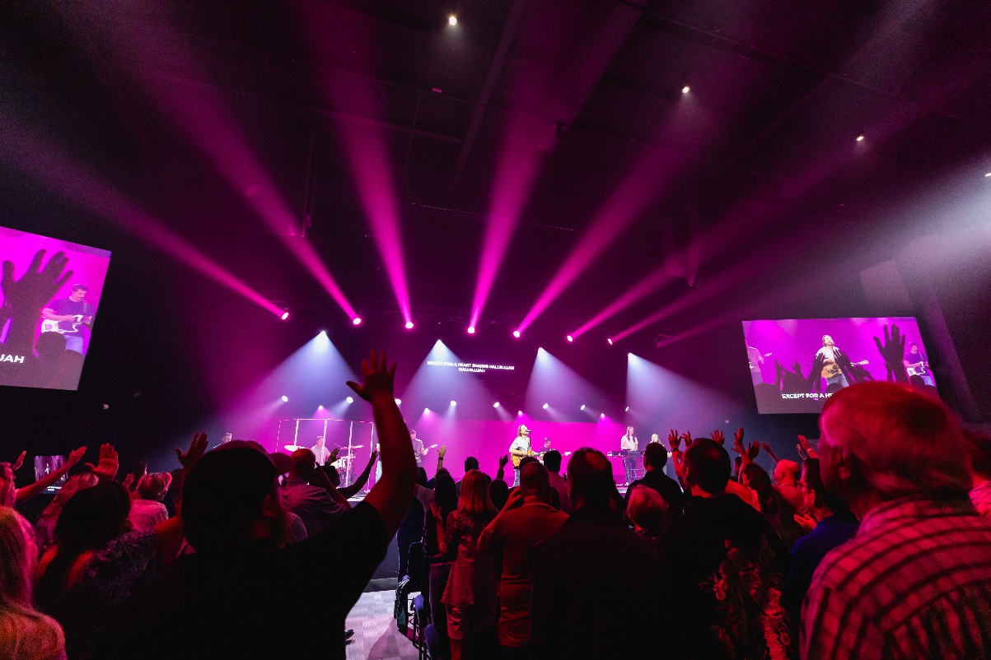

Revolution Church Finds Peace of Mind with Sennheiser Spectera
Exceptional Sound and Unprecedented Reliability with Spectera Wireless System

Canton (GA), USA, 8 October 2025 — Revolution Church, a multi-campus ministry in Georgia with a 20-year history, has upgraded its main broadcast campus in Canton with Sennheiser’s Spectera bidirectional wideband wireless audio ecosystem. This upgrade has solved long-standing challenges with radio frequency (RF) density and provided a superior audio experience for its worship and ministry teams. The new system not only delivers exceptional sound quality but also offers the reliability and flexibility needed to support the church’s diverse and dynamic production schedule, offering peace of mind for all team members and worshippers alike.

With locations currently in Canton and Jasper, “Revolution Church exists to love Jesus and to help people grow in their faith,” shares Brian Damerow, Production and Creative Minister at Revolution Church. Damerow has proudly overseen broadcast and technical teams for more than 13 years. The church serves thousands of people weekly and helps lead a global church planting network. As of late, Damerow was facing the fact that the existing gear was beginning to show its age, experiencing occasional dropouts and becoming increasingly difficult to manage in a crowded RF environment. The Canton campus, which serves as a broadcast hub for other locations and online services, required a robust and future-proof solution.

Damerow admits that he had some reservations going into the project, saying, “I’m normally apprehensive to being an early adopter of technology. I like to let it live out there for a little bit, but after meeting with Sennheiser and a few other companies, I was fully confident to go full steam ahead with Spectera.”

Damerow approached the upgrade with a deep sense of stewardship. “I personally give to this church, and so I also know that my money is going towards these investments,” he explained. His goal was to find a system that was an investment for the foreseeable future, not just a temporary fix. “Trying to have redundancy and resiliency in all of our mission-critical systems is always a goal.” Spectera checked all the boxes and more, and, with the help of the team at Integrated Production Solutions (IPS) Nashville, the system was installed.


Revolution Church depends on a variety of ew G3/G4 300 and 500 series microphone solutions for events, including Sunday Service

The decision to deploy 16 new Spectera bodypacks was a direct response to the nuanced needs of the church. Damerow and his team were particularly drawn to Spectera’s ability to pack a high density of channels into a single TV channel, a critical feature as the RF landscape becomes more complex. The system’s bidirectional capabilities also offered unprecedented versatility. Revolution Church notably deploys a variety of handheld microphones from the evolution wireless G3/G4 300 and 500 series for events.

The easy installation and simple setup process were a revelation. While the team had allocated days to configure the new system, they had it up and running in just 20 minutes. “It was so straightforward, that the whole team was pleasantly surprised at the simplicity of the install,” Damerow recalled. The intuitive web interface and the system’s smart functionality meant they could quickly save and redeploy configurations for different events, from a typical Sunday service to a student panel with multiple headset microphones.

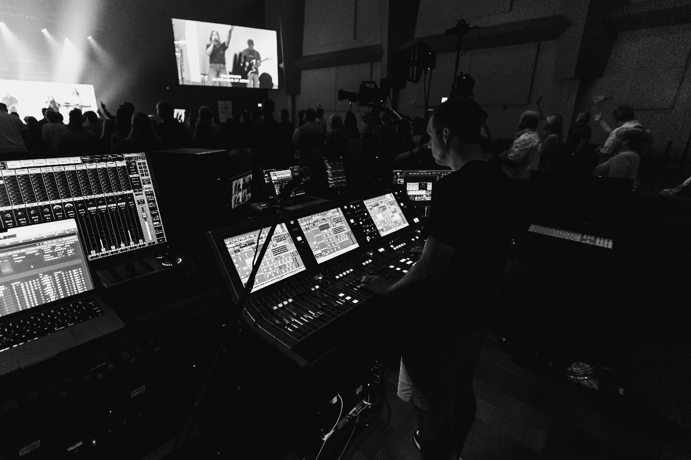
By installing 16 Spectera body packs, Revolution Church was able to provide its production team and performers with clear, reliable sound

To ensure maximum reliability, the church configured a four-antenna setup, taking full advantage of the system’s built-in redundancy. They chose to use MADI for the primary audio input for its low latency, with a Dante network as a redundant failover — a testament to Damerow’s commitment to building a resilient system that minimizes risk.

The impact on the ministry and its production team was immediate and transformative. The most striking improvement was the audio quality. The worship team — a mix of professional and volunteer musicians — experienced a profound difference in their in-ear monitors (IEMs). Damerow described the sensation as “taking the blanket off of our in-ear mixes” as they were able to hear a much wider frequency range and more detail than ever before. This newfound clarity boosted the confidence of the musicians and vocalists, giving them the freedom to perform at their best, which in turn lead to a noticeable improvement in the overall sound for the congregation.

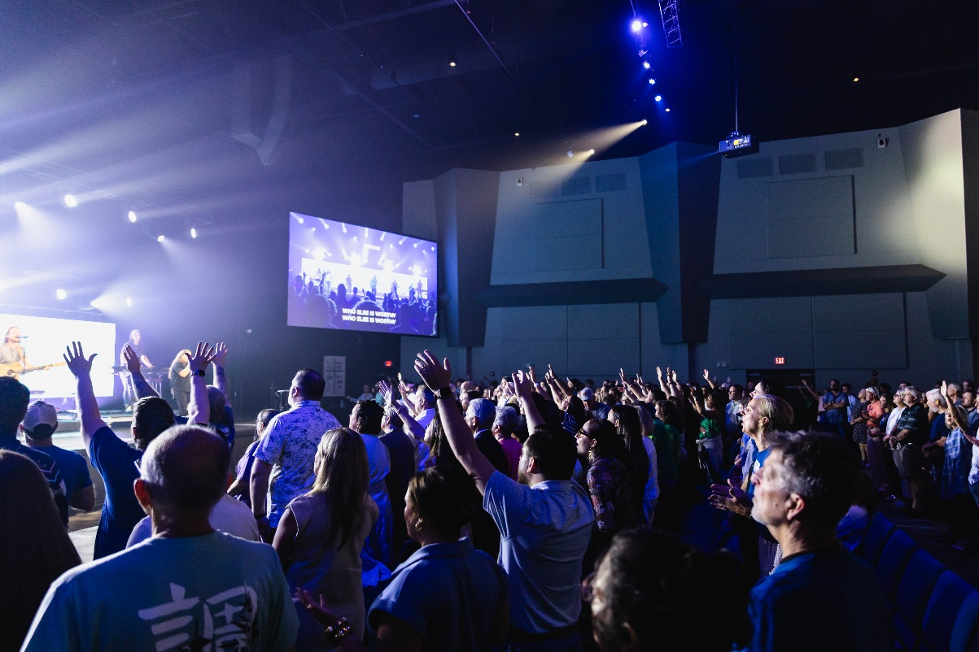
Congregation members are brought together through faith without missing a moment of audio thanks to Spectera

For Damerow, the ultimate success of the Spectera ecosystem has been the serenity and tranquility it provides. The system’s stability and dependability allow him and his team to focus on what matters most: sharing the gospel, rather than spending time regulating technical issues.

“I had very high expectations for Spectera,” Damerow concluded. “And they were all met or exceeded. It’s certainly the solution going forward, and we would recommend Spectera to any other houses of worship as well.”

Michael Casey, director of sales at IPS, added, “We were thrilled to partner with Revolution Church to find the perfect solution. Sennheiser stood out not only for their outstanding support and responsiveness, but for offering a product that delivered the performance, reliability, and features the church required.”

With Spectera on the Canton campus, the wireless gear that was replaced in the main room will now be redeployed to other parts of the facility, providing a cascading upgrade that benefits the entire ministry. The team at Revolution Church sees Spectera not just as a piece of equipment, but as a strategic investment that will continue to support the church’s mission for years to come.

(Ends)

The high-resolution images accompanying this media release can be downloaded here.

About the Sennheiser Brand – 80 Years of Building the Future of Audio
We live and breathe audio. We are driven by the passion to create audio solutions that make a difference. This passion has taken us from the world’s greatest stages to the quietest listening rooms – and made Sennheiser the name behind audio that doesn’t just sound good: It feels true. In 2025, the Sennheiser brand celebrates its 80th anniversary. Since 1945, we have stood for building the future of audio and bringing remarkable sound experiences to our customers. While professional audio solutions such as microphones, meeting solutions, streaming technologies and monitoring systems are part of the business of Sennheiser electronic SE & Co. KG, the business with consumer devices such as headphones, soundbars and speech-enhanced hearables is operated by Sonova Holding AG under the license of Sennheiser.

www.sennheiser.com
www.sennheiser-hearing.com

US/Canada Press Contact
Daniella Kohan Peter Schuyler
daniella.kohan @sennheiser.com Peter@ingearpr.com
+1 (860) 227-2235 +1 (917) 496-8970

